
Responsible Data Analytics
MSc

Fundamentals of Data and
Infrastructure
(LNDN5204)

Student full name: Student ID:
Submission Date: Word Count: 2941

Contents
Title Page No
1. Introduction and Business Scenario 3
1.1 The source relational database 3
2. Star Schema Design 4
2.1 Fact and dimensions — what was chosen and why 4
2.2 Granularity 5
2.3 Why a star schema rather than a snowflake or normalised model 5
3. Derivation of Logical Relations 5
4. Creation of Tables with Integrity Rules 6
5. Data Source Identification, Extraction, Transformation and Loading 7
5.1 Source-to-target mapping 8
5.2 Loading order 8
5.3 Evidence of ETL execution and row counts 9
6. Justification of the Data Mart Design 10
6.1 Business question 1 — four-hour performance by financial year 10
6.2 Business question 2 — busiest A&E sites 11
6.3 Business question 3 — four-hour compliance by health board (2025) 12
6.4 Business question 4 — seasonality by quarter 13
6.5 Business question 5 — longest waits by site (2025) 14
6.6 Comparison and design trade-offs 15
7. Conclusion 15
Management Evaluation Report 16
References 16
Appendix A — Full SQL Scripts 17

1. Introduction and Business Scenario
This report documents the design and prototype implementation of a data mart built in Microsoft SQL Server 2022. The organisational scenario is Public Health Scotland PHS, which publishes NHS performance statistics for Scotland. The specific subject area is unscheduled (Accident and Emergency) care: every month each A and E treatment location in Scotland reports how many patients attended, how many were seen within the four hour national standard, and how many waited longer than 4, 8 and 12 hours.
All data used in this coursework is open data published by Public Health Scotland on its open data platform (opendata.nhs.scot). Three published resources were used as the source operational system: the “Monthly A and E Activity” activity file, the “A and E Hospital Site list” reference file, and the “Health Board 2014 to 2019” geography lookup. Together these span 225 months (July 2007 to March 2026) and 103 distinct treatment locations across the 14 territorial NHS health boards.
Business requirement for a data mart. PHS analysts and health board managers repeatedly ask the same analytical questions: How has the four hour performance changed over time? Which sites and which health boards are under the most pressure? Where do the longest (8h/12h) waits occur, and is there a seasonal winter effect? Answering these from the normalised operational tables requires repeated multi table joins and onthefly parsing of the YYYYMM period string into calendar and financial year buckets. A purpose built, subject oriented data mart that pre integrates these dimensions makes the recurring questions simpler, faster and consistent which is the role of a data mart within a wider warehouse.

1.1 The source relational database
The source system was modelled as a small normalised (3NF) relational database in the schema src, reflecting how an operational system would store the data. It contains one transaction-style table (AEActivity) and two reference tables (HospitalSite and HealthBoard). The entity relationship diagram and the relational definitions of the source are shown in Figure 1.
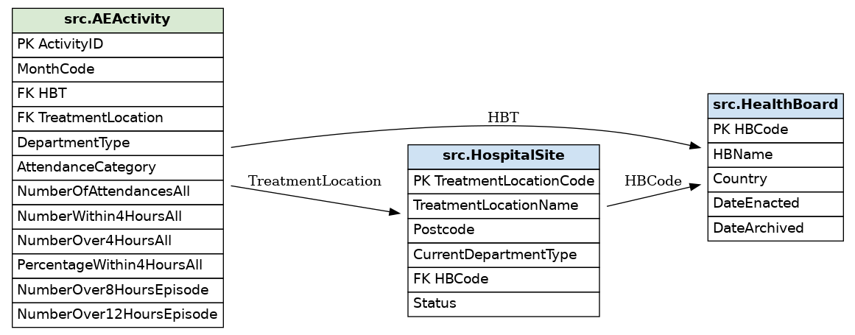
Figure 1 Entity-Relationship diagram of the source relational database (src schema).
Source relational definitions ({PK} Primary key and * Represents Foreign Key):
src.HealthBoard ( HBCode [PK], HBName, Country, DateEnacted, DateArchived )
src.HospitalSite ( TreatmentLocationCode [PK], TreatmentLocationName, Postcode,
CurrentDepartmentType, HBCode* -> HealthBoard, Status )
src.AEActivity ( ActivityID [PK], MonthCode, HBT* -> HealthBoard,
TreatmentLocation* -> HospitalSite, DepartmentType, AttendanceCategory,
NumberOfAttendancesAll, NumberWithin4HoursAll, NumberOver4HoursAll,
PercentageWithin4HoursAll, NumberOver8HoursEpisode, NumberOver12HoursEpisode )
The source loaded with 18 health boards, 103 hospital sites and 39,259 monthly activity records, preserving full referential integrity (evidence in Section 5.3).

2. Star Schema Design — what was chosen and why
Following analysis of the source the data mart was designed as a classic star schema with a single central fact table surrounded by four conformed dimensions. All objects carry the mandatory group4_ prefix.
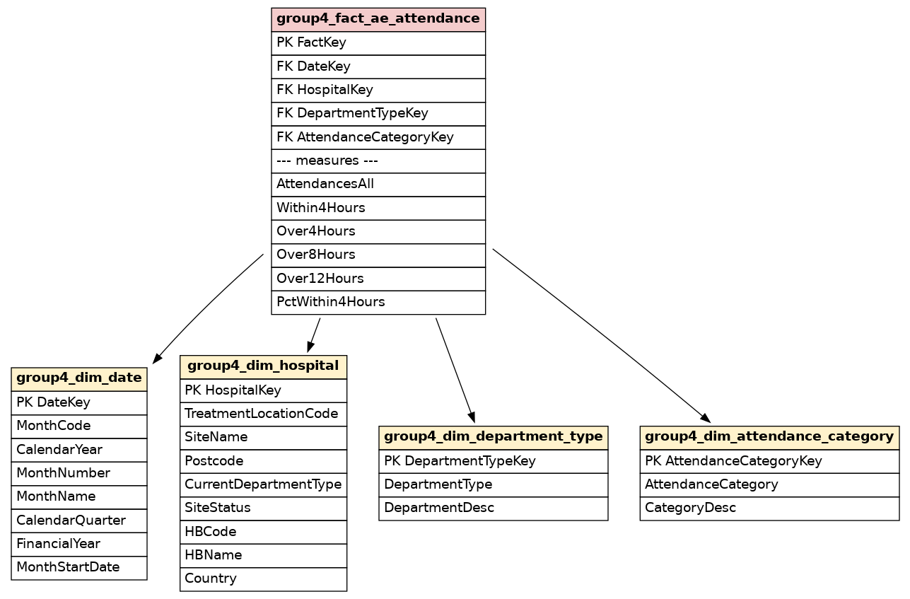
Figure 2 Star schema for the Group 4 A and E data mart

2.1 Fact and dimensions
Fact table group4_fact_ae_attendance. The measures are AttendancesAll, Within4Hours, Over4Hours, Over8Hours and Over12Hours (all fully additive counts that can be summed across every dimension) plus PctWithin4Hours, a non additive ratio that is therefore rederived from the additive counts at query time the mart answer almost any aggregation correctly.
Dimensions. Four dimensions provide the ‘by’ context for the measures:
- group4_dim_date the time context at month grain (calendar year, month, quarter and Scottish financial year). A dedicated date dimension removes the need to parse the YYYYMM string in every query.
- group4_dim_hospital the place context. Hospital site and its parent health board are deliberately denormalised into one dimension (site → health board is a fixed hierarchy), keeping the schema a true star rather than a snowflake.
- group4_dim_department_type the type of A&E service (Type 1 major ED vs Type 3 minor-injury unit), with a decoded description.
- group4_dim_attendance_category whether the figures are All, Unplanned or New-planned attendances.
Attribute selection. Each dimension keeps only attributes that analysts filter, group or label by; volatile or purely operational columns from the source (e.g. provider identifiers, quality-flag columns) were excluded to avoid unjustified redundancy. Descriptive labels (MonthName, HBName, DepartmentDesc) are stored so that report output is human-readable without further joins.

2.2 Granularity
The grain of the fact table is one row per month, per treatment location, per department type, per attendance category. This is the lowest grain available in the published source and is stated explicitly because granularity governs which dimensions are valid and how measures may be aggregated. Holding the data at this atomic grain means higherlevel questions (by health board, by quarter, by financial year, by department type) are all answered by simple aggregation, with no loss of analytical flexibility.

2.3 Why a star schema rather than a snowflake or normalised model
A star schema was chosen a fully normalised (3NF) design and to a snowflake design. A 3NF model minimises redundancy but forces many joins for analysis, which is exactly the cost the data mart is meant to remove. A snowflake would normalise the health board out of the hospital dimension into its own table; while that saves a little storage, it reintroduces a join for the most common grouping (by health board). Denormalising the fixed site→health board hierarchy into a single group4_dim_hospital dimension therefore gives the simplest, fastest model because the dimension is loaded and maintained by the ETL, not edited by hand.

3. Derivation of Logical Relations
The star schema maps to the following logical relations. Primary keys are shown in [PK]; foreign keys are marked * with the relation they reference. Surrogate integer keys (generated by IDENTITY) are used for every dimension so the mart is insulated from changes to the business (natural) keys in the source.
group4_dim_date ( DateKey [PK], MonthCode, CalendarYear, MonthNumber, MonthName,
CalendarQuarter, FinancialYear, MonthStartDate )
group4_dim_hospital ( HospitalKey [PK], TreatmentLocationCode, SiteName, Postcode,
CurrentDepartmentType, SiteStatus, HBCode, HBName, Country )
group4_dim_department_type ( DepartmentTypeKey [PK], DepartmentType, DepartmentDesc )
group4_dim_attendance_category ( AttendanceCategoryKey [PK], AttendanceCategory, CategoryDesc )
group4_fact_ae_attendance ( FactKey [PK], DateKey* -> group4_dim_date,
HospitalKey* -> group4_dim_hospital, DepartmentTypeKey* -> group4_dim_department_type,
AttendanceCategoryKey* -> group4_dim_attendance_category,
AttendancesAll, Within4Hours, Over4Hours, Over8Hours, Over12Hours, PctWithin4Hours )
Mapping explanation. Each point of the star becomes one relation: the central fact relation. The fact relation carries one foreign key per dimension, each referencing that dimension’s surrogate primary key, which enforces the star’s one-to-many relationships. The natural keys retained inside the dimensions (e.g. MonthCode, TreatmentLocationCode) are the business keys used by the ETL to look up the correct surrogate when the fact is loaded.
Primary and foreign keys. The fact’s primary key is the surrogate FactKey. Its four foreign keys are DateKey, HospitalKey, DepartmentTypeKey and AttendanceCategoryKey, group4_dim_date, group4_dim_hospital, group4_dim_department_type and group4_dim_attendance_category. Each dimension’s primary key is its own surrogate key, and each natural/business key carries a UNIQUE constraint so duplicates cannot enter.
Surrogate-key rationale. Every dimension uses an integer IDENTITY surrogate key as its primary key rather than the natural business key from the source. surrogate keys decouple the mart from the operational system, so if a treatment-location code or a period format ever changes the fact table is unaffected; they are narrow integers that make fact-to-dimension joins fast and indexes compact; and they provide a stable place to hold a reserved Unknown member (key −1) for unmatched or late-arriving data. They also lay the groundwork for slowly changing dimensions.

4. Creation of Tables with Integrity Rules
All tables were created in Microsoft SQL Server 2022 with a full set of integrity constraints: surrogate PRIMARY KEYs, UNIQUE constraints on natural keys, NOT NULL rules, DEFAULT values, CHECK constraints for data quality, and FOREIGN KEYs from the fact to every dimension. The complete DDL is in Appendix A; the key statements follow.
Example dimension (date) with UNIQUE, NOT NULL, DEFAULT and CHECK constraints:
CREATE TABLE dbo.group4_dim_date (
DateKey INT IDENTITY(1,1) NOT NULL,
MonthCode CHAR(6) NOT NULL,
CalendarYear SMALLINT NOT NULL,
MonthNumber TINYINT NOT NULL,
MonthName VARCHAR(12) NOT NULL,
CalendarQuarter TINYINT NOT NULL,
FinancialYear CHAR(7) NOT NULL DEFAULT 'Unknown',
MonthStartDate DATE NOT NULL,
CONSTRAINT PK_group4_dim_date PRIMARY KEY (DateKey),
CONSTRAINT UQ_group4_dim_date_month UNIQUE (MonthCode),
CONSTRAINT CK_group4_dim_date_month CHECK (MonthNumber BETWEEN 1 AND 12),
CONSTRAINT CK_group4_dim_date_qtr CHECK (CalendarQuarter BETWEEN 1 AND 4));
Fact table with four foreign keys (ON UPDATE CASCADE / ON DELETE NO ACTION), NOT NULL, DEFAULT 0 and CHECK constraints:
CREATE TABLE dbo.group4_fact_ae_attendance (
FactKey BIGINT IDENTITY(1,1) NOT NULL,
DateKey INT NOT NULL, HospitalKey INT NOT NULL,
DepartmentTypeKey INT NOT NULL, AttendanceCategoryKey INT NOT NULL,
AttendancesAll INT NOT NULL DEFAULT 0, Within4Hours INT NOT NULL DEFAULT 0,
Over4Hours INT NOT NULL DEFAULT 0, Over8Hours INT NOT NULL DEFAULT 0,
Over12Hours INT NOT NULL DEFAULT 0, PctWithin4Hours DECIMAL(5,1) NOT NULL DEFAULT 0,
CONSTRAINT PK_group4_fact_ae_attendance PRIMARY KEY (FactKey),
CONSTRAINT FK_group4_fact_date FOREIGN KEY (DateKey)
REFERENCES dbo.group4_dim_date(DateKey) ON UPDATE CASCADE ON DELETE NO ACTION,
CONSTRAINT FK_group4_fact_hospital FOREIGN KEY (HospitalKey)
REFERENCES dbo.group4_dim_hospital(HospitalKey) ON UPDATE CASCADE ON DELETE NO ACTION,
CONSTRAINT FK_group4_fact_dept FOREIGN KEY (DepartmentTypeKey)
REFERENCES dbo.group4_dim_department_type(DepartmentTypeKey) ON UPDATE CASCADE ON DELETE NO ACTION,
CONSTRAINT FK_group4_fact_cat FOREIGN KEY (AttendanceCategoryKey)
REFERENCES dbo.group4_dim_attendance_category(AttendanceCategoryKey) ON UPDATE CASCADE ON DELETE NO ACTION,
CONSTRAINT CK_group4_fact_nonneg CHECK (AttendancesAll>=0 AND Within4Hours>=0
AND Over4Hours>=0 AND Over8Hours>=0 AND Over12Hours>=0),
CONSTRAINT CK_group4_fact_pct CHECK (PctWithin4Hours BETWEEN 0 AND 100),
CONSTRAINT CK_group4_fact_split CHECK (Within4Hours + Over4Hours <= AttendancesAll));
Design trade-off noted. FOREIGN KEYs use ON UPDATE CASCADE so that any correction to a dimension surrogate key propagates automatically, but ON DELETE NO ACTION so that historical facts can never be silently destroyed by deleting a dimension row protecting the integrity of the warehouse history.
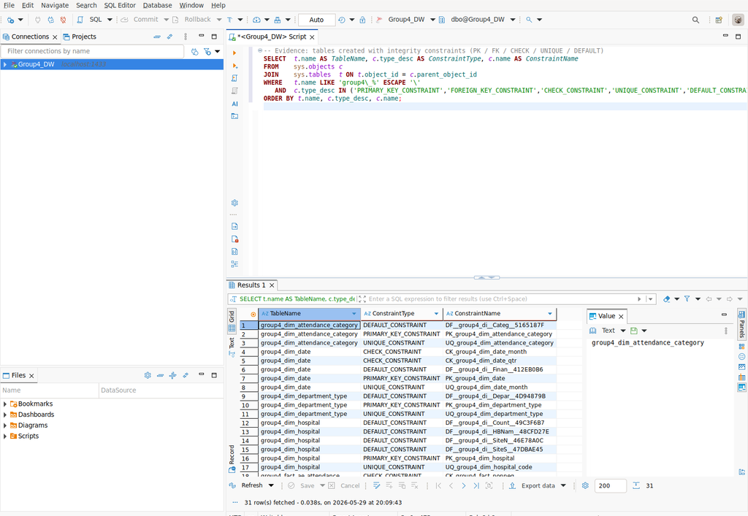
Figure 3 Evidence: 31 integrity constraints (PK, FK, CHECK, UNIQUE, DEFAULT) created across the group4_ tables.

5. Data Source Identification, Extraction, Transformation and Loading
The ETL extracts from the src relational tables and loads the group4_ star schema. Figure 4 shows the source-to-destination map; Table 1 gives the detailed column-level mapping, transformations and filters.
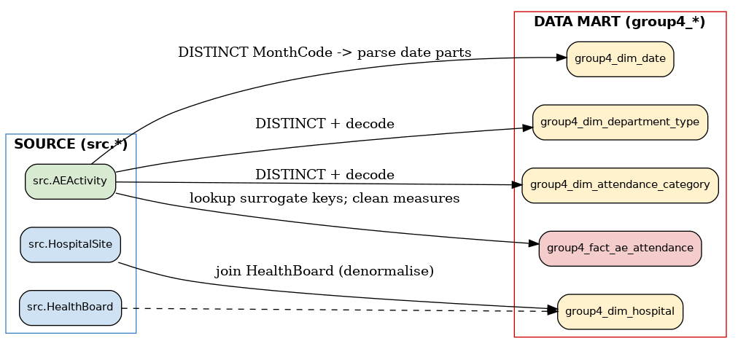
Figure 4 Source-to-destination data flow (src.* → group4_*).

5.1 Source-to-target mapping
Data mart target | Source column(s) | Transformation / rule | Type conversion
dim_date.MonthCode | AEActivity.MonthCode (DISTINCT) | Distinct list of periods | CHAR(6)
dim_date.CalendarYear / MonthNumber | MonthCode | LEFT/RIGHT string split of YYYYMM | -> SMALLINT / TINYINT
dim_date.MonthName / Quarter | MonthCode | DATEFROMPARTS + DATENAME / DATEPART | derived
dim_date.FinancialYear | MonthCode | Apr–Mar Scottish financial-year derivation | -> CHAR(7)
dim_hospital.* | HospitalSite + HealthBoard | Join site to health board (denormalise) | copy
dim_department_type.DepartmentDesc | AEActivity.DepartmentType | DISTINCT + CASE decode of code | derived
dim_attendance_category.CategoryDesc | AEActivity.AttendanceCategory | DISTINCT + CASE decode | derived
fact.(4 surrogate FKs) | AEActivity business keys | Look up surrogate keys via dimension joins | INT
fact.AttendancesAll | NumberOfAttendancesAll, Within/Over4 | GREATEST(total, within+over); COALESCE null->0 | -> INT
fact.Within4/Over4/Over8/Over12 | matching Number* columns | GREATEST(0, COALESCE(.,0)) clamps negatives | -> INT
fact.PctWithin4Hours | PercentageWithin4HoursAll | COALESCE then recompute; clamp 0–100 | -> DECIMAL(5,1)

Table 1 ETL source-to-destination mapping.
Filter and quality rules. (i) Source activity sites missing from the published site list (one historical code, H221B) are inserted as a stub site so the foreign key holds; (ii) two records contain a negative NumberOver4HoursAll (−27, a published correction artefact) which is clamped to zero; (iii) NULL measures are coalesced to zero; (iv) an Unknown member (key −1) is preloaded into every dimension to absorb any unmatched key.

5.2 Loading order
Because the fact has foreign keys to all four dimensions, the load order is strictly dimensions first, fact last. Within the dimensions the Unknown members are inserted first (using SET IDENTITY_INSERT) so they receive the reserved key −1. The fact load then joins each source row to the four dimensions on their business keys to obtain the surrogate keys.
Representative ETL code (fact load; full version in Appendix A.3):
INSERT INTO dbo.group4_fact_ae_attendance
(DateKey,HospitalKey,DepartmentTypeKey,AttendanceCategoryKey,
AttendancesAll,Within4Hours,Over4Hours,Over8Hours,Over12Hours,PctWithin4Hours)
SELECT d.DateKey, h.HospitalKey, dt.DepartmentTypeKey, ac.AttendanceCategoryKey,
GREATEST(COALESCE(a.NumberOfAttendancesAll,0),
GREATEST(0,COALESCE(a.NumberWithin4HoursAll,0))
+GREATEST(0,COALESCE(a.NumberOver4HoursAll,0))),
GREATEST(0,COALESCE(a.NumberWithin4HoursAll,0)),
GREATEST(0,COALESCE(a.NumberOver4HoursAll,0)),
GREATEST(0,COALESCE(a.NumberOver8HoursEpisode,0)),
GREATEST(0,COALESCE(a.NumberOver12HoursEpisode,0)),
LEAST(100.0,GREATEST(0.0,COALESCE(a.PercentageWithin4HoursAll,0)))
FROM src.AEActivity a
JOIN dbo.group4_dim_date d ON d.MonthCode = a.MonthCode
JOIN dbo.group4_dim_hospital h ON h.TreatmentLocationCode = a.TreatmentLocation
JOIN dbo.group4_dim_department_type dt ON dt.DepartmentType = a.DepartmentType
JOIN dbo.group4_dim_attendance_category ac ON ac.AttendanceCategory = a.AttendanceCategory;

5.3 Evidence of ETL execution and row counts
After running the ETL, the rows loaded into each table were verified. The fact table received all 39,259 source activity rows, confirming that every source record matched a valid member in all four dimensions.
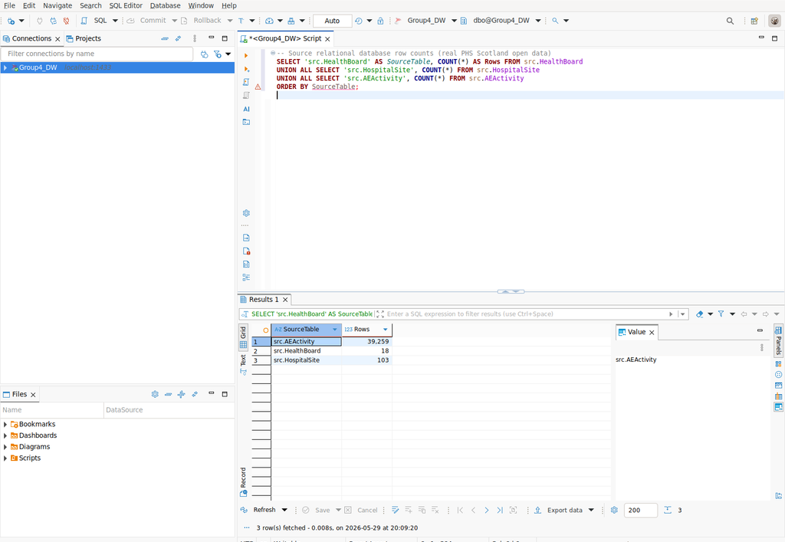
Figure 5 Source relational tables loaded with real PHS data (39,259 activity rows).
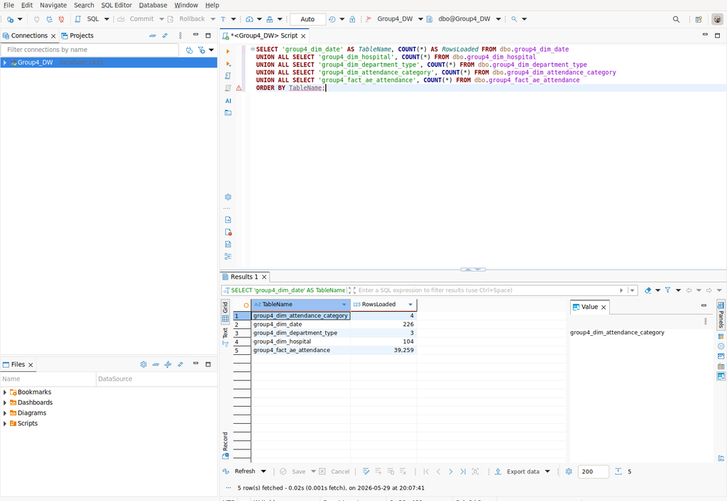
Figure 6 Rows loaded into each data mart dimension and fact table.

6. Justification of the Data Mart Design
Five analytical questions, each answering a stated business requirement, were written against both the data mart (star schema) and the relational source. Every pair returns byte-for-byte identical results verified row by row which both validates the ETL and lets the comparison focus purely on query structure, clarity and performance. In each screenshot the SQL appears in the upper pane and its result with the row count in the lower pane.

6.1 Business question 1 — four hour performance by financial year
Requirement: track the headline four-hour standard over time. The result is striking and real: attendances stay broadly flat (~1.6m/year) yet the share seen within four hours collapses from 97.2% in 2007/08 to 68.5% in 2025/26. On the mart this is a three-table star join with FinancialYear read straight from the date dimension; on the source the financial year must be parsed from the YYYYMM string with nested CASE/CONCAT/CAST in both SELECT and GROUP BY.
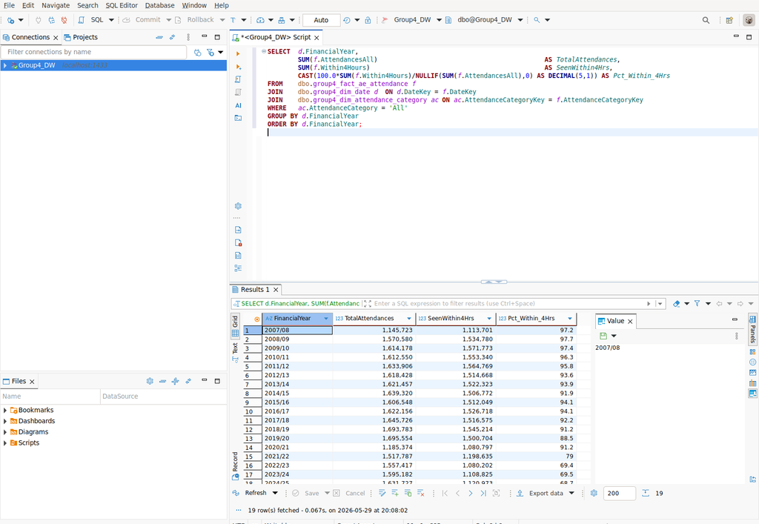
Figure 7 Q1 on the data mart (19 rows).
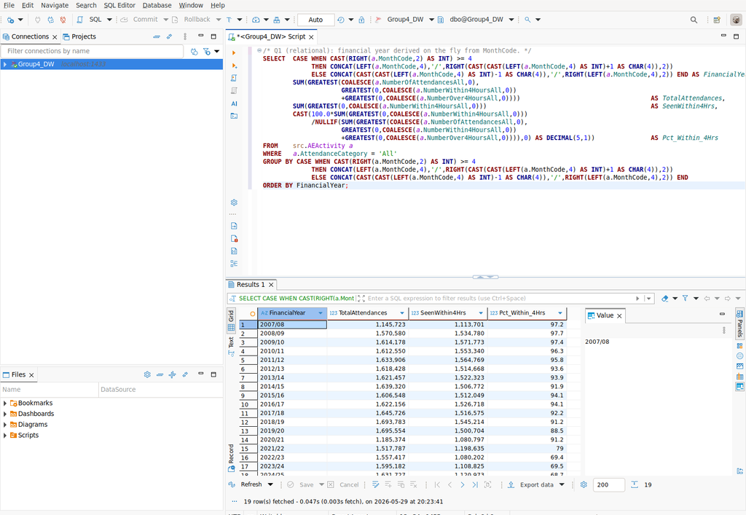
Figure 8 Q1 on the relational source: identical 19 rows, but with in-query date parsing.

6.2 Business question 2 busiest A and E sites
Requirement: identify the highest-volume sites and their health board. The Royal Infirmary of Edinburgh, Glasgow Royal Infirmary and Queen Elizabeth University Hospital lead. The mart reads SiteName and HBName from one denormalised hospital dimension; the source must chain AEActivity → HospitalSite → HealthBoard to recover the names.
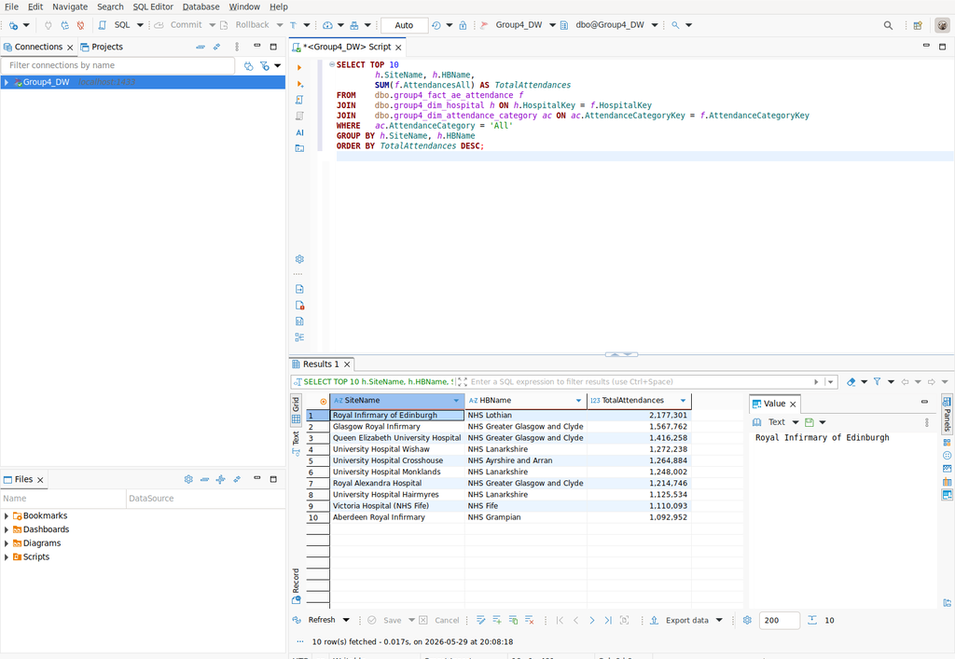
Figure 9 Q2 on the data mart (10 rows).
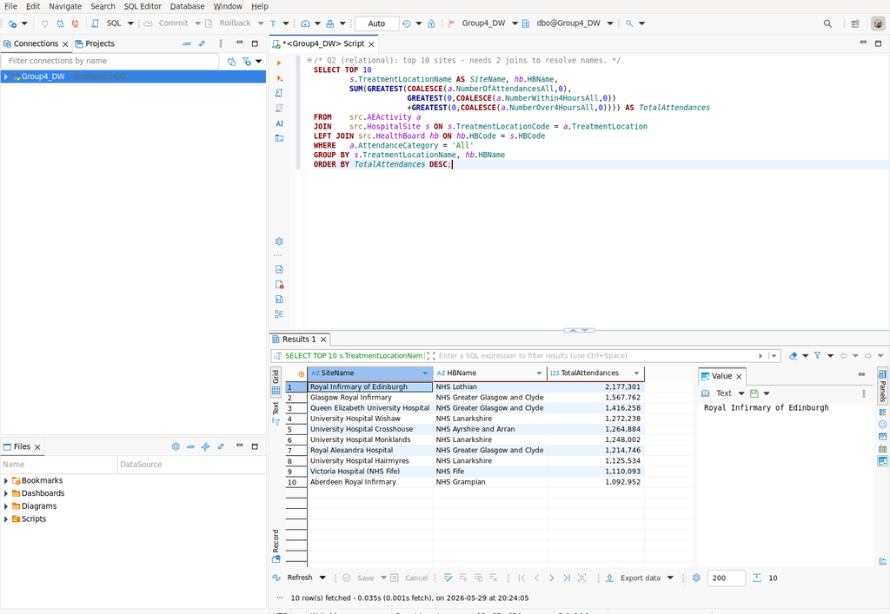
Figure 10 Q2 on the relational source: identical, via a three-table join.

6.3 Business question 3 four hour compliance by health board (2025)
Requirement: find the boards under most pressure. NHS Lanarkshire (54.0%) and NHS Forth Valley (60.8%) are worst; small remote boards (Orkney, Western Isles) perform best. The source query needs both the site→board join and a year filter parsed from the period string.
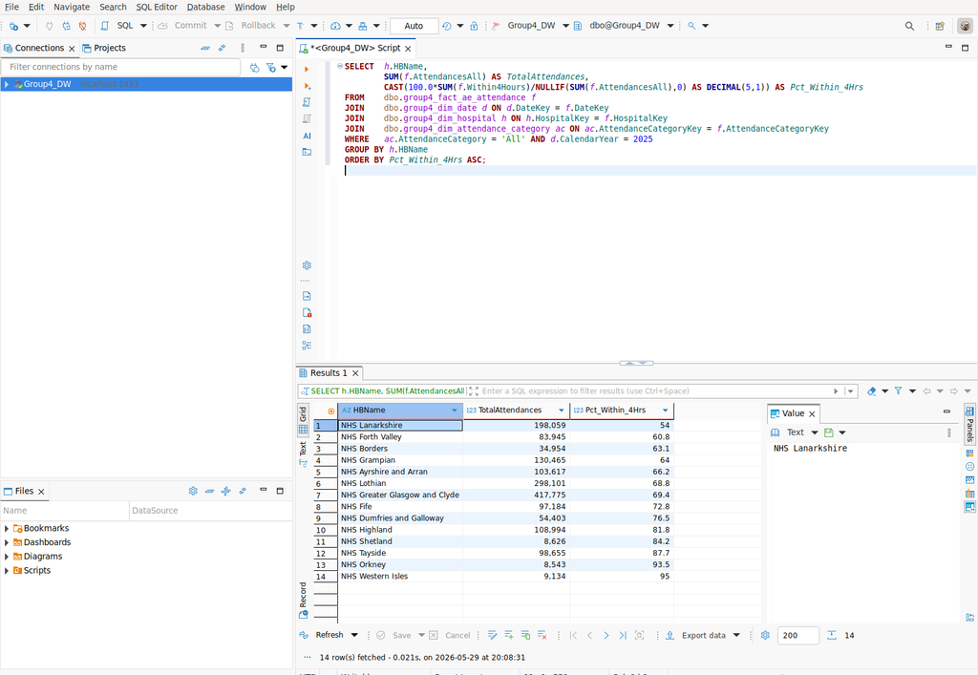
Figure 11 Q3 on the data mart (14 rows).
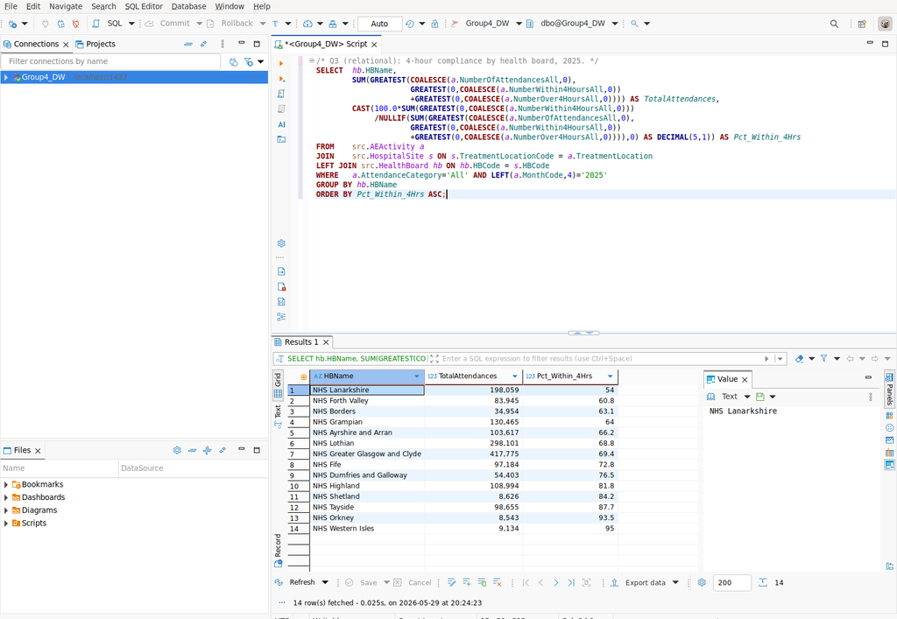
Figure 12 Q3 on the relational source: identical 14 rows.

6.4 Business question 4 seasonality by quarter
Requirement: test for a seasonal pattern. Calendar quarters 3 (Jul–Sep) and 4 (Oct–Dec) carry the highest Type-1 volumes and the highest average monthly attendances per site, with quarter 1 (Jan–Mar) the lowest. On the mart the quarter is a stored attribute (a one-line GROUP BY); on the source it must be derived with DATEFROMPARTS/DATEPART for every row.
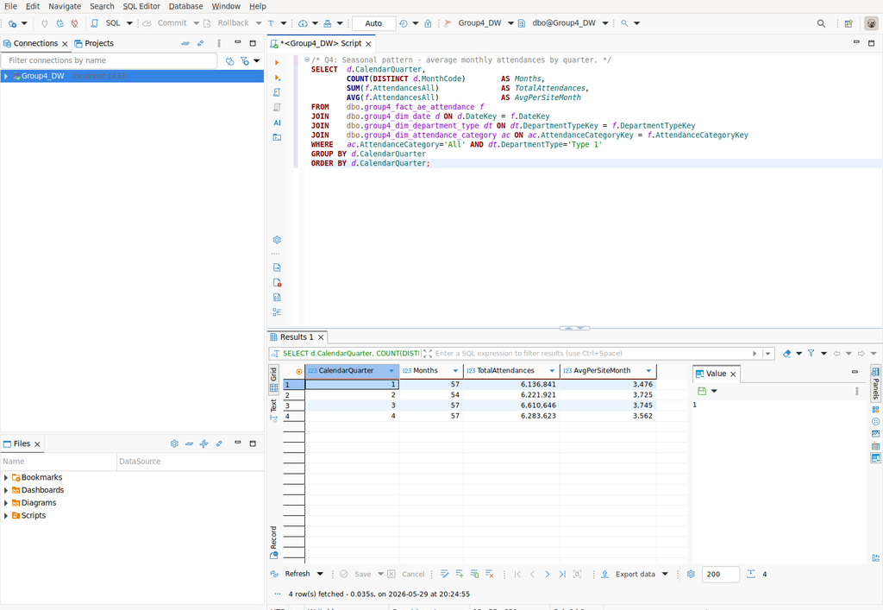
Figure 13 Q4 on the data mart (4 rows).
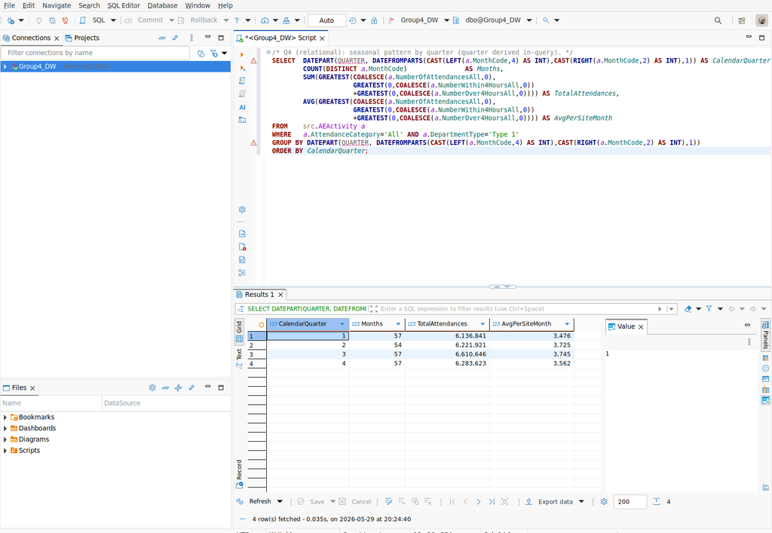
Figure 14 Q4 on the relational source: identical, with in-query quarter derivation.

6.5 Business question 5 longest waits by site (2025)
Requirement: locate where the longest (8h/12h) waits occur. University Hospital Wishaw and the Royal Infirmary of Edinburgh record the most 12-hour waits, pinpointing where escalation is most needed.
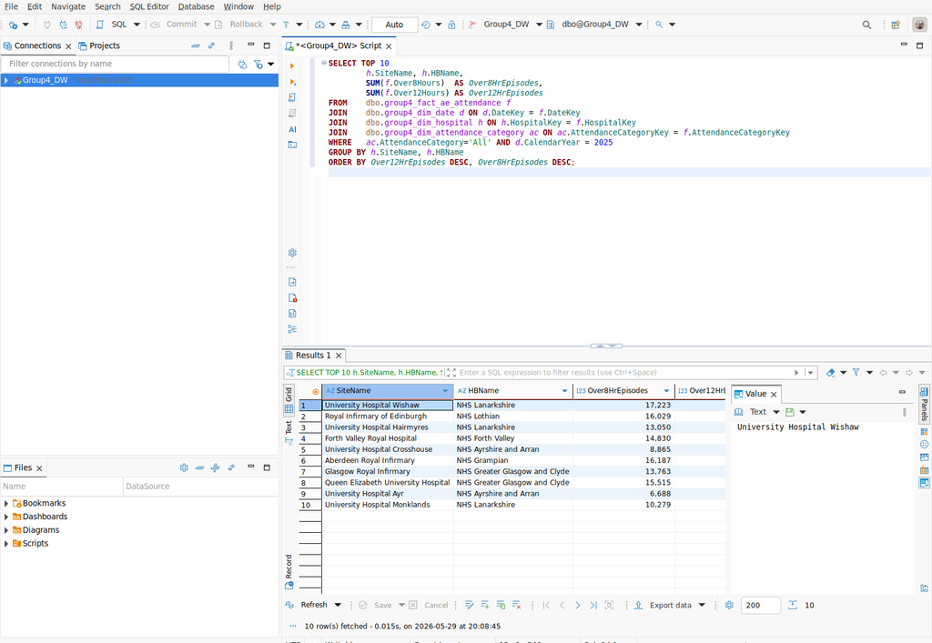
Figure 15 Q5 on the data mart (10 rows).
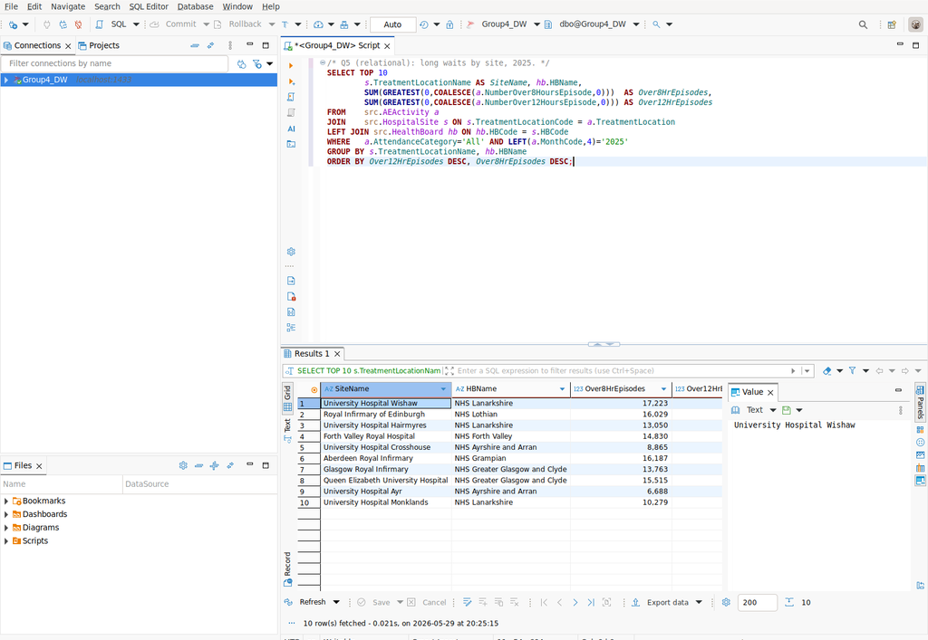
Figure 16 Q5 on the relational source: identical 10 rows.

6.6 Comparison and design trade offs
Table 2 summarises, for each question, what the relational source must do that the data mart has already done. In every case the results are identical, so the data mart loses no information; what changes is the effort and risk.
Business question | Relational source must | Data mart already provides | Result
Q1 FY trend | Parse YYYYMM → financial year (nested CASE/CONCAT/CAST) twice | FinancialYear stored in dim_date | Identical (19 rows)
Q2 busiest sites | Join AEActivity→HospitalSite→HealthBoard (3 tables) | SiteName + HBName in one dimension | Identical (10)
Q3 board compliance | site→board join + parse year filter | HBName + CalendarYear pre-computed | Identical (14)
Q4 seasonality | Derive quarter with DATEFROMPARTS/DATEPART per row | CalendarQuarter stored in dim_date | Identical (4)
Q5 long waits | site→board join + parse year filter | HBName + CalendarYear pre-computed | Identical (10)

Table 2 Data mart vs relational source for each analytical query.
Advantages of the data mart demonstrated by the comparison:
- Simplicity and fewer joins: business logic financial year, the site→healthboard hierarchy, code descriptions is computed once in the ETL and stored in dimensions, so the analytical queries are shorter and read naturally.
- Consistency: every analyst inherits the same FinancialYear and the same health-board grouping from the dimension, removing the risk that two hand-written derivations disagree the kind of subtle error that produced a 27 row difference until the source queries were aligned to the mart data-quality rules.
- Performance and scalability: the star joins narrow integer surrogate keys backed by the four non-clustered indexes on the fact table and avoids perrow string parsing; at production (national HES) volumes this advantage compounds, whereas the relational queries re-parse strings and re-join reference tables on every execution.
- Data quality: the mart enforces non-negative measures and total ≥ components through CHECK constraints, so the published −27 anomaly cannot propagate; the raw relational model has no such guarantee.
- Subject orientation: the mart is organised around the A&E performance process, intuitive for managers, whereas the normalised source is organised for transactional integrity.
Trade-off. The mart introduces controlled redundancy (the health board is repeated per site) and must be refreshed by the ETL, so it is a periodic copy rather than the live operational record. For analytical reporting the purpose here that trade is clearly worthwhile; the comparison above shows the same answers obtained more simply, consistently and with stronger dataquality guarantees than querying the relational source directly.

7. Conclusion
A working prototype data mart was designed and implemented in Microsoft SQL Server using real Public Health Scotland open data. The star schema (one fact, four conformed dimensions) was derived to logical relations with surrogate keys, created with a complete set of integrity constraints, populated by a documented ETL with verified row counts, and validated against the relational source through five analytical queries. The comparison confirms the data mart’s advantages in simplicity, consistency and performance for recurring analytical workloads.

Management Evaluation Report

Student ID | Name | Contribution % | Justification
P2950205 | Muhammad Husnain Nazir | 25% | Led Task 1–2: business-scenario analysis and star-schema design (fact, dimensions, granularity).
P2942610 | Laxmi Bhaveshbhai Bhalala | 25% | Led Task 3–4: derivation of logical relations and creation of tables with integrity constraints (DDL).
P2942539 | Jawad Ahmad | 25% | Led Task 5–6: source-to-target mapping, ETL implementation, loading order and row-count verification.
P2968806 | Devishkumar Rajeshbhai Laheri | 25% | Led Task 7: analytical queries, data-mart vs relational comparison and report compilation.

References
Public Health Scotland (2026) Monthly Accident and Emergency Activity and Waiting Times [Open dataset]. Available at: https://www.opendata.nhs.scot/dataset/monthly-accident-and-emergency-activity-and-waiting-times.
Public Health Scotland (2025) NHS Scotland Accident & Emergency Sites [Open dataset]. Available at: https://www.opendata.nhs.scot/dataset/nhs-scotland-accident-emergency-sites.
Public Health Scotland (2020) Geography Codes and Labels — Health Board 2014–2019 [Open dataset]. Available at: https://www.opendata.nhs.scot/dataset/geography-codes-and-labels.
Kimball, R. and Ross, M. (2013) The Data Warehouse Toolkit: The Definitive Guide to Dimensional Modeling. 3rd edn. Indianapolis: Wiley.

Appendix A Full SQL Scripts

A.1 Source database creation (01_create_source.sql)
IF DB_ID('Group4_DW') IS NULL
CREATE DATABASE Group4_DW;
GO
USE Group4_DW;
GO
IF SCHEMA_ID('src') IS NULL EXEC('CREATE SCHEMA src');
GO
IF OBJECT_ID('src.AEActivity','U') IS NOT NULL DROP TABLE src.AEActivity;
IF OBJECT_ID('src.HospitalSite','U') IS NOT NULL DROP TABLE src.HospitalSite;
IF OBJECT_ID('src.HealthBoard','U') IS NOT NULL DROP TABLE src.HealthBoard;
GO
CREATE TABLE src.HealthBoard (
HBCode CHAR(9) NOT NULL,
HBName VARCHAR(120) NOT NULL,
Country CHAR(9) NULL,
DateEnacted DATE NULL,
DateArchived DATE NULL,
CONSTRAINT PK_src_HealthBoard PRIMARY KEY (HBCode)
);
GO
CREATE TABLE src.HospitalSite (
TreatmentLocationCode CHAR(5) NOT NULL,
TreatmentLocationName VARCHAR(150) NULL,
Postcode VARCHAR(10) NULL,
CurrentDepartmentType VARCHAR(20) NULL,
HBCode CHAR(9) NULL,
Status VARCHAR(20) NULL,
CONSTRAINT PK_src_HospitalSite PRIMARY KEY (TreatmentLocationCode),
CONSTRAINT FK_src_Site_HB FOREIGN KEY (HBCode) REFERENCES src.HealthBoard(HBCode)
);
GO
CREATE TABLE src.AEActivity (
ActivityID INT IDENTITY(1,1) NOT NULL,
MonthCode CHAR(6) NOT NULL, -- YYYYMM
HBT CHAR(9) NOT NULL, -- health board of treatment
TreatmentLocation CHAR(5) NOT NULL, -- site code
DepartmentType VARCHAR(20) NOT NULL,
AttendanceCategory VARCHAR(20) NOT NULL,
NumberOfAttendancesAll INT NULL,
NumberWithin4HoursAll INT NULL,
NumberOver4HoursAll INT NULL,
PercentageWithin4HoursAll DECIMAL(5,1) NULL,
NumberOver8HoursEpisode INT NULL,
NumberOver12HoursEpisode INT NULL,
CONSTRAINT PK_src_AEActivity PRIMARY KEY (ActivityID),
CONSTRAINT FK_src_Act_HB FOREIGN KEY (HBT) REFERENCES src.HealthBoard(HBCode),
CONSTRAINT FK_src_Act_Site FOREIGN KEY (TreatmentLocation) REFERENCES src.HospitalSite(TreatmentLocationCode)
);
GO

A.2 Data mart creation (02_create_datamart.sql)
USE Group4_DW;
GO
IF OBJECT_ID('dbo.group4_fact_ae_attendance','U') IS NOT NULL DROP TABLE dbo.group4_fact_ae_attendance;
IF OBJECT_ID('dbo.group4_dim_date','U') IS NOT NULL DROP TABLE dbo.group4_dim_date;
IF OBJECT_ID('dbo.group4_dim_hospital','U') IS NOT NULL DROP TABLE dbo.group4_dim_hospital;
IF OBJECT_ID('dbo.group4_dim_department_type','U') IS NOT NULL DROP TABLE dbo.group4_dim_department_type;
IF OBJECT_ID('dbo.group4_dim_attendance_category','U') IS NOT NULL DROP TABLE dbo.group4_dim_attendance_category;
GO
CREATE TABLE dbo.group4_dim_date (
DateKey INT IDENTITY(1,1) NOT NULL,
MonthCode CHAR(6) NOT NULL, -- business key YYYYMM
CalendarYear SMALLINT NOT NULL,
MonthNumber TINYINT NOT NULL,
MonthName VARCHAR(12) NOT NULL,
CalendarQuarter TINYINT NOT NULL,
FinancialYear CHAR(7) NOT NULL DEFAULT 'Unknown', -- e.g. 2025/26
MonthStartDate DATE NOT NULL,
CONSTRAINT PK_group4_dim_date PRIMARY KEY (DateKey),
CONSTRAINT UQ_group4_dim_date_month UNIQUE (MonthCode),
CONSTRAINT CK_group4_dim_date_month CHECK (MonthNumber BETWEEN 1 AND 12),
CONSTRAINT CK_group4_dim_date_qtr CHECK (CalendarQuarter BETWEEN 1 AND 4)
);
GO
CREATE TABLE dbo.group4_dim_hospital (
HospitalKey INT IDENTITY(1,1) NOT NULL,
TreatmentLocationCode CHAR(5) NOT NULL, -- business key
SiteName VARCHAR(150) NOT NULL DEFAULT 'Unknown',
Postcode VARCHAR(10) NULL,
CurrentDepartmentType VARCHAR(20) NULL,
SiteStatus VARCHAR(20) NOT NULL DEFAULT 'Unknown',
HBCode CHAR(9) NULL,
HBName VARCHAR(120) NOT NULL DEFAULT 'Unknown',
Country VARCHAR(20) NOT NULL DEFAULT 'Scotland',
CONSTRAINT PK_group4_dim_hospital PRIMARY KEY (HospitalKey),
CONSTRAINT UQ_group4_dim_hospital_code UNIQUE (TreatmentLocationCode)
);
GO
CREATE TABLE dbo.group4_dim_department_type (
DepartmentTypeKey INT IDENTITY(1,1) NOT NULL,
DepartmentType VARCHAR(20) NOT NULL,
DepartmentDesc VARCHAR(80) NOT NULL DEFAULT 'Unknown',
CONSTRAINT PK_group4_dim_department_type PRIMARY KEY (DepartmentTypeKey),
CONSTRAINT UQ_group4_dim_department_type UNIQUE (DepartmentType)
);
GO
CREATE TABLE dbo.group4_dim_attendance_category (
AttendanceCategoryKey INT IDENTITY(1,1) NOT NULL,
AttendanceCategory VARCHAR(20) NOT NULL,
CategoryDesc VARCHAR(80) NOT NULL DEFAULT 'Unknown',
CONSTRAINT PK_group4_dim_attendance_category PRIMARY KEY (AttendanceCategoryKey),
CONSTRAINT UQ_group4_dim_attendance_category UNIQUE (AttendanceCategory)
);
GO
CREATE TABLE dbo.group4_fact_ae_attendance (
FactKey BIGINT IDENTITY(1,1) NOT NULL,
DateKey INT NOT NULL,
HospitalKey INT NOT NULL,
DepartmentTypeKey INT NOT NULL,
AttendanceCategoryKey INT NOT NULL,
AttendancesAll INT NOT NULL DEFAULT 0,
Within4Hours INT NOT NULL DEFAULT 0,
Over4Hours INT NOT NULL DEFAULT 0,
Over8Hours INT NOT NULL DEFAULT 0,
Over12Hours INT NOT NULL DEFAULT 0,
PctWithin4Hours DECIMAL(5,1) NOT NULL DEFAULT 0,
CONSTRAINT PK_group4_fact_ae_attendance PRIMARY KEY (FactKey),
/* Referential integrity to every dimension; ON UPDATE CASCADE keeps
surrogate keys aligned, ON DELETE NO ACTION protects fact history. */
CONSTRAINT FK_group4_fact_date FOREIGN KEY (DateKey)
REFERENCES dbo.group4_dim_date(DateKey) ON UPDATE CASCADE ON DELETE NO ACTION,
CONSTRAINT FK_group4_fact_hospital FOREIGN KEY (HospitalKey)
REFERENCES dbo.group4_dim_hospital(HospitalKey) ON UPDATE CASCADE ON DELETE NO ACTION,
CONSTRAINT FK_group4_fact_dept FOREIGN KEY (DepartmentTypeKey)
REFERENCES dbo.group4_dim_department_type(DepartmentTypeKey) ON UPDATE CASCADE ON DELETE NO ACTION,
CONSTRAINT FK_group4_fact_cat FOREIGN KEY (AttendanceCategoryKey)
REFERENCES dbo.group4_dim_attendance_category(AttendanceCategoryKey) ON UPDATE CASCADE ON DELETE NO ACTION,
CONSTRAINT CK_group4_fact_nonneg CHECK (AttendancesAll >= 0 AND Within4Hours >= 0
AND Over4Hours >= 0 AND Over8Hours >= 0 AND Over12Hours >= 0),
CONSTRAINT CK_group4_fact_pct CHECK (PctWithin4Hours BETWEEN 0 AND 100),
CONSTRAINT CK_group4_fact_split CHECK (Within4Hours + Over4Hours <= AttendancesAll)
);
GO
CREATE INDEX IX_group4_fact_date ON dbo.group4_fact_ae_attendance(DateKey);
CREATE INDEX IX_group4_fact_hospital ON dbo.group4_fact_ae_attendance(HospitalKey);
CREATE INDEX IX_group4_fact_dept ON dbo.group4_fact_ae_attendance(DepartmentTypeKey);
CREATE INDEX IX_group4_fact_cat ON dbo.group4_fact_ae_attendance(AttendanceCategoryKey);
GO

A.3 ETL (03_etl.sql)
USE Group4_DW;
GO
DELETE FROM dbo.group4_fact_ae_attendance;
DELETE FROM dbo.group4_dim_date;
DELETE FROM dbo.group4_dim_hospital;
DELETE FROM dbo.group4_dim_department_type;
DELETE FROM dbo.group4_dim_attendance_category;
GO
SET IDENTITY_INSERT dbo.group4_dim_date ON;
INSERT INTO dbo.group4_dim_date (DateKey,MonthCode,CalendarYear,MonthNumber,MonthName,CalendarQuarter,FinancialYear,MonthStartDate)
VALUES (-1,'000000',1900,1,'Unknown',1,'Unknown','1900-01-01');
SET IDENTITY_INSERT dbo.group4_dim_date OFF;
SET IDENTITY_INSERT dbo.group4_dim_hospital ON;
INSERT INTO dbo.group4_dim_hospital (HospitalKey,TreatmentLocationCode,SiteName,SiteStatus,HBName,Country)
VALUES (-1,'00000','Unknown','Unknown','Unknown','Unknown');
SET IDENTITY_INSERT dbo.group4_dim_hospital OFF;
SET IDENTITY_INSERT dbo.group4_dim_department_type ON;
INSERT INTO dbo.group4_dim_department_type (DepartmentTypeKey,DepartmentType,DepartmentDesc)
VALUES (-1,'Unknown','Unknown');
SET IDENTITY_INSERT dbo.group4_dim_department_type OFF;
SET IDENTITY_INSERT dbo.group4_dim_attendance_category ON;
INSERT INTO dbo.group4_dim_attendance_category (AttendanceCategoryKey,AttendanceCategory,CategoryDesc)
VALUES (-1,'Unknown','Unknown');
SET IDENTITY_INSERT dbo.group4_dim_attendance_category OFF;
GO
Transform: parse YYYYMM string -> calendar parts; derive the
Scottish financial year (Apr-Mar) and the month start date. */
INSERT INTO dbo.group4_dim_date
(MonthCode,CalendarYear,MonthNumber,MonthName,CalendarQuarter,FinancialYear,MonthStartDate)
SELECT m.MonthCode,
CAST(LEFT(m.MonthCode,4) AS SMALLINT) AS CalendarYear,
CAST(RIGHT(m.MonthCode,2) AS TINYINT) AS MonthNumber,
DATENAME(MONTH, DATEFROMPARTS(CAST(LEFT(m.MonthCode,4) AS INT),
CAST(RIGHT(m.MonthCode,2) AS INT),1)) AS MonthName,
DATEPART(QUARTER, DATEFROMPARTS(CAST(LEFT(m.MonthCode,4) AS INT),
CAST(RIGHT(m.MonthCode,2) AS INT),1)) AS CalendarQuarter,
CONCAT(fy.FYStart,'/',RIGHT(CAST(fy.FYStart+1 AS CHAR(4)),2)) AS FinancialYear,
DATEFROMPARTS(CAST(LEFT(m.MonthCode,4) AS INT),CAST(RIGHT(m.MonthCode,2) AS INT),1) AS MonthStartDate
FROM (SELECT DISTINCT MonthCode FROM src.AEActivity) m
CROSS APPLY (SELECT CASE WHEN CAST(RIGHT(m.MonthCode,2) AS INT) >= 4
THEN CAST(LEFT(m.MonthCode,4) AS INT)
ELSE CAST(LEFT(m.MonthCode,4) AS INT)-1 END AS FYStart) fy;
GO
(TreatmentLocationCode,SiteName,Postcode,CurrentDepartmentType,SiteStatus,HBCode,HBName,Country)
SELECT s.TreatmentLocationCode,
COALESCE(s.TreatmentLocationName,'Unknown'),
s.Postcode,
s.CurrentDepartmentType,
COALESCE(s.Status,'Unknown'),
s.HBCode,
COALESCE(hb.HBName,'Unknown'),
'Scotland'
FROM src.HospitalSite s
LEFT JOIN src.HealthBoard hb ON hb.HBCode = s.HBCode;
GO
INSERT INTO dbo.group4_dim_department_type (DepartmentType,DepartmentDesc)
SELECT DISTINCT a.DepartmentType,
CASE a.DepartmentType
WHEN 'Type 1' THEN 'Emergency Department (consultant-led, major)'
WHEN 'Type 2' THEN 'Single specialty A&E'
WHEN 'Type 3' THEN 'Minor Injury Unit / Other A&E service'
ELSE 'Other' END
FROM src.AEActivity a;
GO
INSERT INTO dbo.group4_dim_attendance_category (AttendanceCategory,CategoryDesc)
SELECT DISTINCT a.AttendanceCategory,
CASE a.AttendanceCategory
WHEN 'All' THEN 'All attendances (planned + unplanned)'
WHEN 'Unplanned' THEN 'Unplanned / emergency attendances'
WHEN 'New planned' THEN 'New planned return attendances'
ELSE 'Other' END
FROM src.AEActivity a;
GO
INSERT INTO dbo.group4_fact_ae_attendance
(DateKey,HospitalKey,DepartmentTypeKey,AttendanceCategoryKey,
AttendancesAll,Within4Hours,Over4Hours,Over8Hours,Over12Hours,PctWithin4Hours)
SELECT d.DateKey, h.HospitalKey, dt.DepartmentTypeKey, ac.AttendanceCategoryKey,
GREATEST(COALESCE(a.NumberOfAttendancesAll,0),
GREATEST(0,COALESCE(a.NumberWithin4HoursAll,0))
+GREATEST(0,COALESCE(a.NumberOver4HoursAll,0))) AS AttendancesAll,
GREATEST(0,COALESCE(a.NumberWithin4HoursAll,0)) AS Within4Hours,
GREATEST(0,COALESCE(a.NumberOver4HoursAll,0)) AS Over4Hours,
GREATEST(0,COALESCE(a.NumberOver8HoursEpisode,0)) AS Over8Hours,
GREATEST(0,COALESCE(a.NumberOver12HoursEpisode,0)) AS Over12Hours,
LEAST(100.0, GREATEST(0.0, COALESCE(a.PercentageWithin4HoursAll,
CASE WHEN COALESCE(a.NumberOfAttendancesAll,0) > 0
THEN 100.0*COALESCE(a.NumberWithin4HoursAll,0)/a.NumberOfAttendancesAll
ELSE 0 END))) AS PctWithin4Hours
FROM src.AEActivity a
JOIN dbo.group4_dim_date d ON d.MonthCode = a.MonthCode
JOIN dbo.group4_dim_hospital h ON h.TreatmentLocationCode = a.TreatmentLocation
JOIN dbo.group4_dim_department_type dt ON dt.DepartmentType = a.DepartmentType
JOIN dbo.group4_dim_attendance_category ac ON ac.AttendanceCategory = a.AttendanceCategory;
GO

A.4 Row counts (04_rowcounts.sql)
USE Group4_DW;
GO
SELECT 'group4_dim_date' AS TableName, COUNT(*) AS RowCountLoaded FROM dbo.group4_dim_date
UNION ALL SELECT 'group4_dim_hospital', COUNT(*) FROM dbo.group4_dim_hospital
UNION ALL SELECT 'group4_dim_department_type', COUNT(*) FROM dbo.group4_dim_department_type
UNION ALL SELECT 'group4_dim_attendance_category', COUNT(*) FROM dbo.group4_dim_attendance_category
UNION ALL SELECT 'group4_fact_ae_attendance', COUNT(*) FROM dbo.group4_fact_ae_attendance
ORDER BY TableName;
GO

A.5 Analytical queries — data mart (05_analysis_datamart.sql)
USE Group4_DW;
GO
SELECT d.FinancialYear,
SUM(f.AttendancesAll) AS TotalAttendances,
SUM(f.Within4Hours) AS SeenWithin4Hrs,
CAST(100.0*SUM(f.Within4Hours)/NULLIF(SUM(f.AttendancesAll),0) AS DECIMAL(5,1)) AS Pct_Within_4Hrs
FROM dbo.group4_fact_ae_attendance f
JOIN dbo.group4_dim_date d ON d.DateKey = f.DateKey
JOIN dbo.group4_dim_attendance_category ac ON ac.AttendanceCategoryKey = f.AttendanceCategoryKey
WHERE ac.AttendanceCategory = 'All'
GROUP BY d.FinancialYear
ORDER BY d.FinancialYear;
GO
h.SiteName, h.HBName,
SUM(f.AttendancesAll) AS TotalAttendances
FROM dbo.group4_fact_ae_attendance f
JOIN dbo.group4_dim_hospital h ON h.HospitalKey = f.HospitalKey
JOIN dbo.group4_dim_attendance_category ac ON ac.AttendanceCategoryKey = f.AttendanceCategoryKey
WHERE ac.AttendanceCategory = 'All'
GROUP BY h.SiteName, h.HBName
ORDER BY TotalAttendances DESC;
GO
SELECT h.HBName,
SUM(f.AttendancesAll) AS TotalAttendances,
CAST(100.0*SUM(f.Within4Hours)/NULLIF(SUM(f.AttendancesAll),0) AS DECIMAL(5,1)) AS Pct_Within_4Hrs
FROM dbo.group4_fact_ae_attendance f
JOIN dbo.group4_dim_date d ON d.DateKey = f.DateKey
JOIN dbo.group4_dim_hospital h ON h.HospitalKey = f.HospitalKey
JOIN dbo.group4_dim_attendance_category ac ON ac.AttendanceCategoryKey = f.AttendanceCategoryKey
WHERE ac.AttendanceCategory = 'All' AND d.CalendarYear = 2025
GROUP BY h.HBName
ORDER BY Pct_Within_4Hrs ASC;
GO
SELECT d.CalendarQuarter,
COUNT(DISTINCT d.MonthCode) AS Months,
SUM(f.AttendancesAll) AS TotalAttendances,
AVG(f.AttendancesAll) AS AvgPerSiteMonth
FROM dbo.group4_fact_ae_attendance f
JOIN dbo.group4_dim_date d ON d.DateKey = f.DateKey
JOIN dbo.group4_dim_department_type dt ON dt.DepartmentTypeKey = f.DepartmentTypeKey
JOIN dbo.group4_dim_attendance_category ac ON ac.AttendanceCategoryKey = f.AttendanceCategoryKey
WHERE ac.AttendanceCategory='All' AND dt.DepartmentType='Type 1'
GROUP BY d.CalendarQuarter
ORDER BY d.CalendarQuarter;
GO
SELECT TOP 10
h.SiteName, h.HBName,
SUM(f.Over8Hours) AS Over8HrEpisodes,
SUM(f.Over12Hours) AS Over12HrEpisodes
FROM dbo.group4_fact_ae_attendance f
JOIN dbo.group4_dim_date d ON d.DateKey = f.DateKey
JOIN dbo.group4_dim_hospital h ON h.HospitalKey = f.HospitalKey
JOIN dbo.group4_dim_attendance_category ac ON ac.AttendanceCategoryKey = f.AttendanceCategoryKey
WHERE ac.AttendanceCategory='All' AND d.CalendarYear = 2025
GROUP BY h.SiteName, h.HBName
ORDER BY Over12HrEpisodes DESC, Over8HrEpisodes DESC;
GO

A.6 Analytical queries — relational source (06_analysis_relational.sql)
USE Group4_DW;
GO
SELECT CASE WHEN CAST(RIGHT(a.MonthCode,2) AS INT) >= 4
THEN CONCAT(LEFT(a.MonthCode,4),'/',RIGHT(CAST(CAST(LEFT(a.MonthCode,4) AS INT)+1 AS CHAR(4)),2))
ELSE CONCAT(CAST(CAST(LEFT(a.MonthCode,4) AS INT)-1 AS CHAR(4)),'/',RIGHT(LEFT(a.MonthCode,4),2)) END AS FinancialYear,
SUM(GREATEST(COALESCE(a.NumberOfAttendancesAll,0),
GREATEST(0,COALESCE(a.NumberWithin4HoursAll,0))
+GREATEST(0,COALESCE(a.NumberOver4HoursAll,0)))) AS TotalAttendances,
SUM(GREATEST(0,COALESCE(a.NumberWithin4HoursAll,0))) AS SeenWithin4Hrs,
CAST(100.0*SUM(GREATEST(0,COALESCE(a.NumberWithin4HoursAll,0)))
/NULLIF(SUM(GREATEST(COALESCE(a.NumberOfAttendancesAll,0),
GREATEST(0,COALESCE(a.NumberWithin4HoursAll,0))
+GREATEST(0,COALESCE(a.NumberOver4HoursAll,0)))),0) AS DECIMAL(5,1)) AS Pct_Within_4Hrs
FROM src.AEActivity a
WHERE a.AttendanceCategory = 'All'
GROUP BY CASE WHEN CAST(RIGHT(a.MonthCode,2) AS INT) >= 4
THEN CONCAT(LEFT(a.MonthCode,4),'/',RIGHT(CAST(CAST(LEFT(a.MonthCode,4) AS INT)+1 AS CHAR(4)),2))
ELSE CONCAT(CAST(CAST(LEFT(a.MonthCode,4) AS INT)-1 AS CHAR(4)),'/',RIGHT(LEFT(a.MonthCode,4),2)) END
ORDER BY FinancialYear;
GO
SELECT TOP 10
s.TreatmentLocationName AS SiteName, hb.HBName,
SUM(GREATEST(COALESCE(a.NumberOfAttendancesAll,0),
GREATEST(0,COALESCE(a.NumberWithin4HoursAll,0))
+GREATEST(0,COALESCE(a.NumberOver4HoursAll,0)))) AS TotalAttendances
FROM src.AEActivity a
JOIN src.HospitalSite s ON s.TreatmentLocationCode = a.TreatmentLocation
LEFT JOIN src.HealthBoard hb ON hb.HBCode = s.HBCode
WHERE a.AttendanceCategory = 'All'
GROUP BY s.TreatmentLocationName, hb.HBName
ORDER BY TotalAttendances DESC;
GO
SELECT hb.HBName,
SUM(GREATEST(COALESCE(a.NumberOfAttendancesAll,0),
GREATEST(0,COALESCE(a.NumberWithin4HoursAll,0))
+GREATEST(0,COALESCE(a.NumberOver4HoursAll,0)))) AS TotalAttendances,
CAST(100.0*SUM(GREATEST(0,COALESCE(a.NumberWithin4HoursAll,0)))
/NULLIF(SUM(GREATEST(COALESCE(a.NumberOfAttendancesAll,0),
GREATEST(0,COALESCE(a.NumberWithin4HoursAll,0))
+GREATEST(0,COALESCE(a.NumberOver4HoursAll,0)))),0) AS DECIMAL(5,1)) AS Pct_Within_4Hrs
FROM src.AEActivity a
JOIN src.HospitalSite s ON s.TreatmentLocationCode = a.TreatmentLocation
LEFT JOIN src.HealthBoard hb ON hb.HBCode = s.HBCode
WHERE a.AttendanceCategory='All' AND LEFT(a.MonthCode,4)='2025'
GROUP BY hb.HBName
ORDER BY Pct_Within_4Hrs ASC;
GO
SELECT DATEPART(QUARTER, DATEFROMPARTS(CAST(LEFT(a.MonthCode,4) AS INT),CAST(RIGHT(a.MonthCode,2) AS INT),1)) AS CalendarQuarter,
COUNT(DISTINCT a.MonthCode) AS Months,
SUM(GREATEST(COALESCE(a.NumberOfAttendancesAll,0),
GREATEST(0,COALESCE(a.NumberWithin4HoursAll,0))
+GREATEST(0,COALESCE(a.NumberOver4HoursAll,0)))) AS TotalAttendances,
AVG(GREATEST(COALESCE(a.NumberOfAttendancesAll,0),
GREATEST(0,COALESCE(a.NumberWithin4HoursAll,0))
+GREATEST(0,COALESCE(a.NumberOver4HoursAll,0)))) AS AvgPerSiteMonth
FROM src.AEActivity a
WHERE a.AttendanceCategory='All' AND a.DepartmentType='Type 1'
GROUP BY DATEPART(QUARTER, DATEFROMPARTS(CAST(LEFT(a.MonthCode,4) AS INT),CAST(RIGHT(a.MonthCode,2) AS INT),1))
ORDER BY CalendarQuarter;
GO
SELECT TOP 10
s.TreatmentLocationName AS SiteName, hb.HBName,
SUM(GREATEST(0,COALESCE(a.NumberOver8HoursEpisode,0))) AS Over8HrEpisodes,
SUM(GREATEST(0,COALESCE(a.NumberOver12HoursEpisode,0))) AS Over12HrEpisodes
FROM src.AEActivity a
JOIN src.HospitalSite s ON s.TreatmentLocationCode = a.TreatmentLocation
LEFT JOIN src.HealthBoard hb ON hb.HBCode = s.HBCode
WHERE a.AttendanceCategory='All' AND LEFT(a.MonthCode,4)='2025'
GROUP BY s.TreatmentLocationName, hb.HBName
ORDER BY Over12HrEpisodes DESC, Over8HrEpisodes DESC;
GO

